****

AMERICAN CLASSIC INTRA-MATIC AUTO

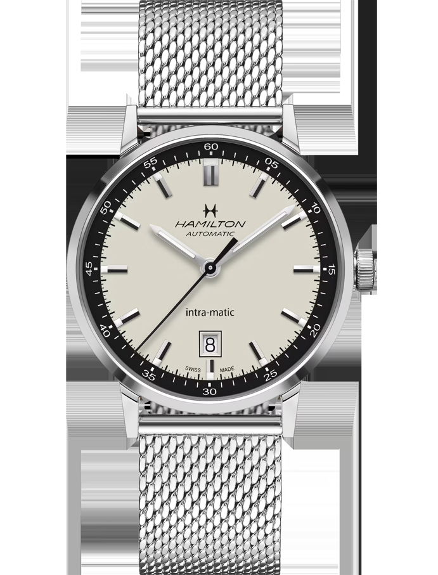

Product Details:

Automatic | 40mm | H38425120

CHF 1,030.00

Recommended retail price (incl. VAT)

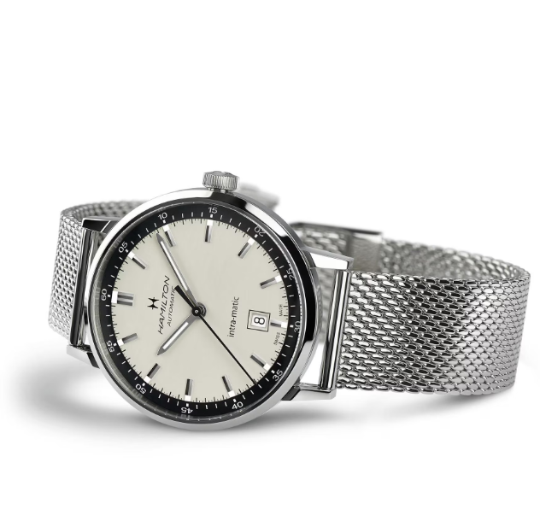With a striking two-tone dial, the Intra-Matic Automatic has a vintage-infused style that will transition from the office to a weekend getaway without missing a beat. Powered by our exclusive H-10 movement featuring the anti-magnetic alloy Nivachron, this standout 40mm timepiece is precise, reliable and full of character.